SIMATS ENGINEERING
ASSESSMENT TOOL 1

COURSE NAME: Database Management Systems
COURSE CODE: CSA05

COURSE OUTCOME COVERED

CO5: Implement database operations using query processing, optimization, and transaction management to ensure consistency and reliability. (BL3, BL4)

Activity Tool : Constraint-Based Problem Solving (High)
Assessment Tool Weightage: 35%

Dr

QUESTIONS Total Marks: 50
Q.No | Question | Bloom's Level | Marks
1 | Given a complex SQL query with nested joins and sub-queries, draw the query execution plan and apply heuristic optimization rules step-by-step. | BL4 – Analyze | 5
2 | Apply cost-based optimization to choose between nested-loop join, sort-merge join, and hash join for the given relations with specified tuple counts and page sizes. | BL4 – Analyze | 5
3 | Implement JDBC connectivity in Java to a MySQL database and write code to execute parameterized queries with PreparedStatement. | BL3 – Apply | 5
4 | Given a schedule of four concurrent transactions, determine whether it is conflict-serializable using a precedence graph. | BL4 – Analyze | 5
5 | Demonstrate the application of Basic Two-Phase Locking (2PL) on a given transaction set. Identify and resolve any deadlocks. | BL3 – Apply | 5
6 | Apply the Wait-Die and Wound-Wait timestamp-based deadlock prevention schemes on a given set of transactions requesting locks. | BL4 – Analyze | 5
7 | Given transaction logs with checkpoints, apply the Immediate Update recovery protocol to recover the database after a system failure. | BL3 – Apply | 5
8 | Apply Deferred Update (NO-UNDO/REDO) recovery technique on a given log file with committed and uncommitted transactions. | BL3 – Apply | 5
9 | Design a concurrency control mechanism using strict 2PL for a banking system where T1 transfers funds and T2 reads balance simultaneously. | BL4 – Analyze | 5
10 | Write pseudocode for query optimization using heuristics: push down selection, project early, and order joins by smaller intermediate results. | BL4 – Analyze | 5

Code of Conduct:

I NITTHYENDREN JS 192421180 certify that this submission is my original work and that I have adhered to the guidelines specified for this assessment.
I understand that any violation of academic integrity rules will result in disciplinary action.

Signature of the student:


RUBRICS FOR CALCULATION:

Constraint-Based Problem Solving Assessment Rubric
Criteria | Weightage | Level 4 (Exemplary) | Level 3 (Proficient) | Level 2 (Developing) | Level 1 (Beginning)
Problem Understanding | 25% | Clearly defines the problem and identifies all relevant constraints accurately | Identifies most constraints with minor gaps | Partial understanding; misses key constraints | Fails to identify constraints correctly
Constraint Analysis | 25% | Analyzes constraints effectively and prioritizes them logically | Provides reasonable analysis with some prioritization | Limited analysis; weak prioritization | No meaningful analysis or prioritization
Solution Development | 25% | Develops optimal and feasible solutions satisfying all constraints | Develops workable solutions with minor limitations | Solutions partially satisfy constraints | Solutions do not meet constraints
Application of Concepts | 15% | Effectively applies appropriate concepts, methods, or tools | Applies concepts with minor errors | Limited application; requires guidance | Unable to apply relevant concepts
Justification | 10% | Provides strong justification for decisions with logical reasoning | Provides justification with some clarity | Weak or unclear justification | No justification provided

ANSWERS

Q1. Query Execution Plan + Heuristic Optimization — 5 Marks
Example query: SELECT S.SName FROM Student S, Enrollment E, Course C WHERE S.SID=E.SID AND E.CID=C.CID AND C.CName='DBMS' AND S.Dept='CSE';
Diagram — Naive plan vs Optimized plan
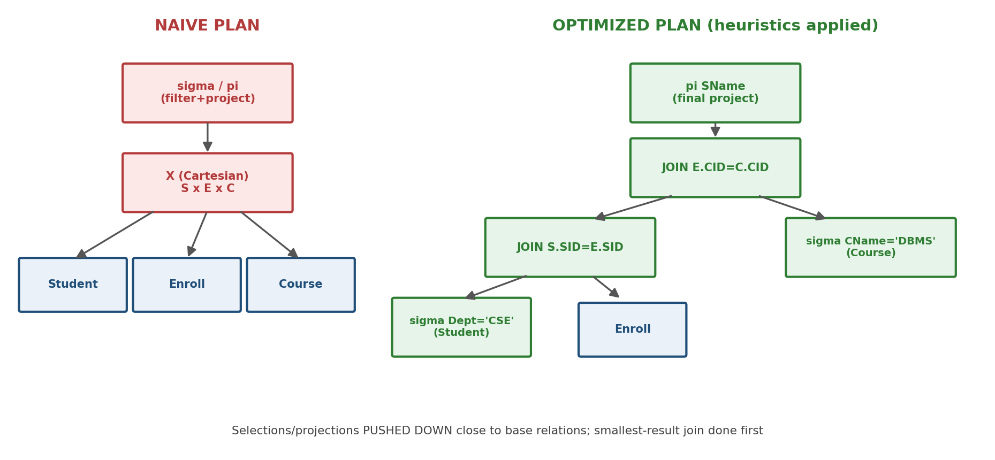

Heuristic rules applied, step by step
• 1. Break the conjunctive WHERE clause into individual selection conditions (C.CName='DBMS' and S.Dept='CSE' treated separately).
• 2. Push each selection DOWN as far as possible, right next to the base relation it references -- filter Student by Dept before any join, filter Course by CName before any join.
• 3. Push the final projection (SName only) down where possible, so intermediate joins carry the fewest columns.
• 4. Replace the Cartesian product + later filter with a direct JOIN on the actual join condition (S.SID=E.SID, E.CID=C.CID) -- never materialize a full cross product.
• 5. Reorder the joins so the join expected to produce the SMALLEST intermediate result runs first (filtered Student joined with Enrollment, before joining the filtered Course).
Analysis: the optimized plan never builds the full |Student| x |Enrollment| x |Course| cross product; every operator works on the smallest possible intermediate relation at each step, which is the entire goal of heuristic (rule-based) query optimization.

Q2. Cost-Based Optimization — NLJ vs Sort-Merge vs Hash Join — 5 Marks
Given constraints
Relation | Tuples | Tuples/Page | Pages
R | 1,000,000 | 100 | 10,000
S | 5,000 | 100 | 50

Available buffer pages B = 22. Join condition: R.key = S.key.
Cost formulas and calculation
Method | Formula (I/O pages) | Calculation | Total Cost
Block Nested-Loop  (S as outer, R inner) | pages(S) + ceil(pages(S)/(B-2)) x pages(R) | 50 + ceil(50/20) x 10000 = 50 + 3x10000 | 30,050
Hash Join  (Grace hash, 1 pass) | 3 x (pages(R) + pages(S)) | 3 x (10000 + 50) | 30,150
Sort-Merge Join | SortCost(R) + SortCost(S) + (pages(R)+pages(S)) | 80,000 + 200 + 10,050 | 90,250

Decision and justification
The optimizer picks Block Nested-Loop Join here -- NOT the commonly assumed 'best default' Hash Join -- because S is so much smaller than R (only 50 pages) that it fits into just 3 buffer-sized chunks; scanning R three times (30,050 I/Os) is marginally cheaper than the double read-write partitioning overhead of Hash Join (30,150 I/Os). Sort-Merge is clearly worst here since R (10,000 pages) is not already sorted and sorting it is very expensive.
• If S grew larger (e.g. beyond ~B-2 buffer-sized chunks), Hash Join would overtake Block Nested-Loop, since NLJ's cost scales with the NUMBER of outer chunks needed.
• If both relations were already sorted on the join key (e.g. via an existing index), Sort-Merge would become the cheapest choice, since its expensive sort phase would be skipped entirely.

Q3. JDBC Connectivity to MySQL with PreparedStatement — 5 Marks
Scenario: transfer funds between two accounts using a PreparedStatement inside an explicit transaction, so the whole operation is atomic (ties directly into CO5's transaction management focus).
import java.sql.*;

public class FundTransfer {
public static void main(String[] args) {
String url = "jdbc:mysql://localhost:3306/bankdb";
String user = "root", password = "yourpassword";

String debitSQL = "UPDATE Account SET balance = balance - ? WHERE acc_id = ?";
String creditSQL = "UPDATE Account SET balance = balance + ? WHERE acc_id = ?";

try (Connection conn = DriverManager.getConnection(url, user, password)) {
conn.setAutoCommit(false); // start transaction

try (PreparedStatement debit = conn.prepareStatement(debitSQL);
PreparedStatement credit = conn.prepareStatement(creditSQL)) {

double amount = 5000.00;
int fromAcc = 101, toAcc = 102;

debit.setDouble(1, amount);
debit.setInt(2, fromAcc);
debit.executeUpdate();

credit.setDouble(1, amount);
credit.setInt(2, toAcc);
credit.executeUpdate();

conn.commit(); // both updates succeed together
System.out.println("Transfer successful.");

} catch (SQLException innerEx) {
conn.rollback(); // undo partial work on failure
System.out.println("Transfer failed, rolled back: " + innerEx.getMessage());
}
} catch (SQLException connEx) {
connEx.printStackTrace();
}
}
}
Why PreparedStatement, and why explicit commit/rollback
• PreparedStatement pre-compiles the SQL once and binds parameters (setDouble/setInt) safely, preventing SQL injection and avoiding the cost of re-parsing the query on every call.
• setAutoCommit(false) groups the debit and credit into ONE transaction; if either update throws an SQLException, rollback() undoes the already-applied debit, preserving atomicity.
• try-with-resources ensures Connection/PreparedStatement objects are always closed, even on exception, avoiding connection leaks.

Q4. Conflict-Serializability via Precedence Graph — 5 Marks
Given schedule S over four transactions on items A, B, C:
T1: R(A)
T2: W(A)
T1: W(B)
T3: R(B)
T3: W(C)
T4: R(C)
T4: W(A)
Conflicting pairs identified (same data item, at least one WRITE, in program order)
Operation pair | Item | Conflict type | Edge added
T1:R(A) before T2:W(A) | A | Read-Write | T1 -> T2
T1:W(B) before T3:R(B) | B | Write-Read | T1 -> T3
T1:R(A) before T4:W(A) | A | Read-Write | T1 -> T4
T2:W(A) before T4:W(A) | A | Write-Write | T2 -> T4
T3:W(C) before T4:R(C) | C | Write-Read | T3 -> T4

Diagram — Precedence Graph
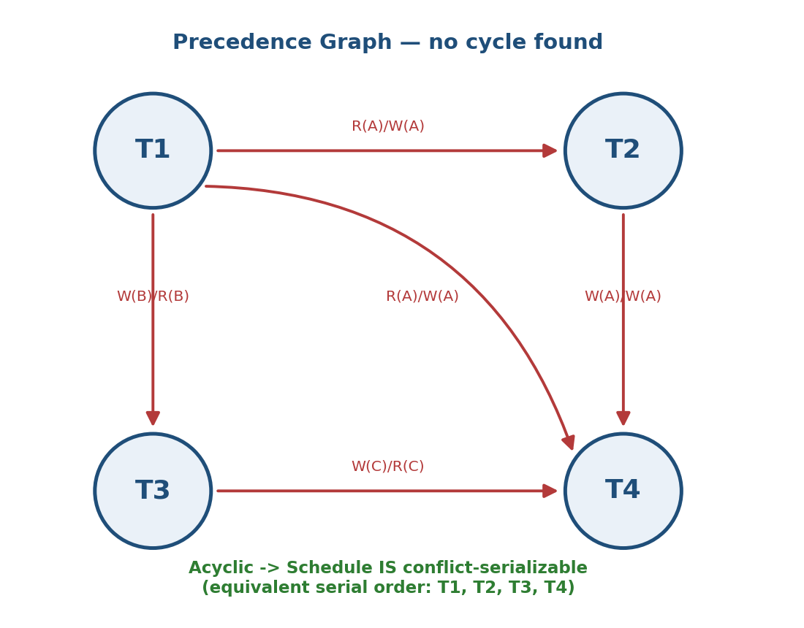

Conclusion
The graph contains NO cycle (every edge points from a lower-numbered to a higher-numbered transaction here), so schedule S IS conflict-serializable. A valid equivalent serial order is any topological sort of the graph -- T1, T2, T3, T4 satisfies every edge and is therefore a correct serial equivalent.

Q5. Basic Two-Phase Locking — Demonstration and Deadlock Resolution — 5 Marks
Transaction set: T1 needs locks on A then B; T2 needs locks on B then A (classic lock-ordering conflict).
Lock request timeline
Time | T1 | T2 | State
t1 | Lock-X(A) [granted] | - | T1 growing phase begins
t2 | - | Lock-X(B) [granted] | T2 growing phase begins
t3 | Lock-X(B) [WAITS - held by T2] | - | T1 blocked
t4 | - | Lock-X(A) [WAITS - held by T1] | T2 blocked
t5 | DEADLOCK: T1 waits for T2, T2 waits for T1 |  | cycle detected

Deadlock identification
T1 holds A and waits for B (held by T2); T2 holds B and waits for A (held by T1) -- a direct 2-cycle in the wait-for graph (T1 -> T2 -> T1), confirming deadlock.
Resolution
• The deadlock detector picks a victim (e.g. the younger transaction, or the one with less work invested) -- say T2 -- and ABORTS it, releasing its lock on B.
• T1 then acquires Lock-X(B), completes its Growing Phase, does its work, and enters the Shrinking Phase (releases A and B only after all locks are acquired, per Basic 2PL's rule that no new lock may be taken once the first lock is released).
• T2 is restarted from the beginning once T1 commits and releases its locks.

Q6. Wait-Die vs Wound-Wait Deadlock Prevention — 5 Marks
Transactions with timestamps (lower TS = older): T1(TS=10), T2(TS=20), T3(TS=30). T2 currently holds a lock on item X. T1 and T3 each request a conflicting lock on X.
Wait-Die scheme (older waits for younger; younger dies/aborts)
Requester | Holder | Requester older? | Decision (Wait-Die)
T1 (TS=10) | T2 (TS=20) | Yes (10 < 20) | T1 WAITS
T3 (TS=30) | T2 (TS=20) | No (30 > 20) | T3 DIES (aborts, restarts later with SAME original timestamp 30)

Wound-Wait scheme (older wounds/preempts younger; younger waits)
Requester | Holder | Requester older? | Decision (Wound-Wait)
T1 (TS=10) | T2 (TS=20) | Yes (10 < 20) | T1 WOUNDS T2 (T2 is aborted and restarted; T1 gets the lock)
T3 (TS=30) | T2 (TS=20) | No (30 > 20) | T3 WAITS

Analysis
Both schemes guarantee freedom from deadlock by only ever letting an OLDER transaction wait (never a younger one indefinitely), but they differ in who is punished: Wait-Die aborts the REQUESTER when it is younger; Wound-Wait aborts the HOLDER when the requester is older. Wound-Wait tends to cause fewer restarts in practice because older transactions actively preempt rather than passively dying.

Q7. Immediate Update Recovery with Checkpoints — 5 Marks
Given transaction log (checkpoint taken between T2's commit and T4's start):
<T1 start> <T1, A, 100, 200> <T1 commit>
<T2 start> <T2, B, 50, 80> <T2 commit>
<CHECKPOINT>
<T3 start> <T3, C, 10, 40>
<T4 start> <T4, D, 5, 9> <T4 commit>
--- SYSTEM CRASH ---
Classifying transactions at crash time
Transaction | Status at crash | Action
T1 | Committed BEFORE checkpoint | No action needed (already durable)
T2 | Committed BEFORE checkpoint | No action needed
T3 | Active, NOT committed | UNDO (roll back C to 10)
T4 | Committed AFTER checkpoint | REDO (reapply D: 5 -> 9)

Recovery steps (Immediate Update: writes may already be on disk before commit)
• Scan backward from the crash point to the checkpoint, building the UNDO list (active, uncommitted transactions) and REDO list (committed transactions found after the checkpoint).
• UNDO phase (in reverse log order): for T3, restore item C to its BEFORE-image value (10), since T3's partial write to disk (if any) must not survive.
• REDO phase (in forward log order): for T4, reapply the AFTER-image (D=9), guaranteeing its committed write is durable even if it hadn't reached disk before the crash.
• T1 and T2 need no action since they committed before the checkpoint and are guaranteed durable.

Q8. Deferred Update (NO-UNDO/REDO) Recovery — 5 Marks
Given log (Deferred Update means NO write touches disk until AFTER commit, so uncommitted transactions never need undoing):
<T1 start> <T1, A, 200> <T1 commit>
<T2 start> <T2, B, 80>
<T3 start> <T3, C, 40> <T3 commit>
--- SYSTEM CRASH --- (T2 never committed)
Classifying transactions
Transaction | Status at crash | Action under NO-UNDO/REDO
T1 | Committed | REDO: reapply A=200
T2 | NOT committed | IGNORE -- no undo needed; its writes were never applied to disk in the first place
T3 | Committed | REDO: reapply C=40

Recovery steps
• Scan the log forward from the last checkpoint (or start).
• For every <T, item, value, commit> pair belonging to a COMMITTED transaction, REDO by writing 'value' to the item -- even if it may already be correct, redo is idempotent and safe to repeat.
• For any transaction with NO matching <commit> record (T2), simply skip it entirely: since Deferred Update never writes to the database before commit, there is nothing on disk to undo.
Analysis: Deferred Update trades a larger in-memory write buffer (all changes held until commit) for a SIMPLER recovery algorithm -- only REDO is ever needed, UNDO logic can be omitted entirely, unlike Immediate Update (Q7) which needs both.

Q9. Strict 2PL Concurrency Control — Banking Scenario — 5 Marks
T1 transfers funds: debit Account A, credit Account B. T2 concurrently reads the balance of Account A. Under Strict 2PL, ALL locks (read and write) are held until COMMIT/ABORT -- never released early -- which specifically prevents T2 from ever seeing T1's uncommitted (dirty) intermediate balance.
Lock schedule enforcing correctness
Time | T1 (transfer) | T2 (read balance) | Outcome
t1 | Lock-X(A); debit A | - | T1 holds exclusive lock on A
t2 | - | Requests Lock-S(A) | T2 BLOCKED -- A locked by T1
t3 | Lock-X(B); credit B | (still waiting) | T1 completes its writes
t4 | COMMIT -> releases Lock-X(A), Lock-X(B) | - | locks freed only now (strict 2PL)
t5 | - | Lock-S(A) granted; reads A | T2 sees only the FINAL, committed balance

Justification
Because Strict 2PL withholds T1's locks until commit, T2 cannot read Account A while T1's debit is only partially applied -- this directly prevents the dirty-read and also guarantees T1 is fully recoverable (nothing else could have read its uncommitted data), which is exactly why Strict 2PL is the standard concurrency-control baseline for financial systems where correctness matters more than throughput.

Q10. Pseudocode for Heuristic Query Optimization — 5 Marks
This formalizes the same three heuristics visually demonstrated in Q1's query-tree diagram.
FUNCTION optimizeQuery(queryTree)

// Rule 1: Push down selections as far toward the leaves as possible
FOR each selection node (sigma) in queryTree:
WHILE selection can move closer to a base relation
without changing the query's meaning:
move selection down past the join/product above it

// Rule 2: Push down (early) projections to shrink tuple width ASAP
FOR each projection node (pi) in queryTree:
WHILE projection can move closer to a base relation:
insert a projection immediately above that relation,
keeping only columns needed by later operators

// Rule 3: Order joins by increasing estimated intermediate result size
joinList = all join operators remaining in queryTree
SORT joinList by estimatedResultSize(join) ASCENDING
rebuild queryTree so joins execute in that sorted order,
smallest-expected-result join first

RETURN queryTree // now an OPTIMIZED execution plan

FUNCTION estimatedResultSize(join)
RETURN size(leftInput) * size(rightInput) / distinctValues(joinAttribute)
// standard selectivity-based cardinality estimate
Explanation
• Pushing selections down means every operator above works on fewer rows -- filtering early is almost always a net win since it can only shrink data flowing upward.
• Pushing projections down (removing unneeded columns as early as possible) reduces the tuple width carried through every subsequent join, lowering memory and I/O cost per operator.
• Ordering joins by smallest estimated intermediate result first keeps every downstream join working on the smallest possible input, compounding the savings -- this is the same principle applied numerically in Q2's cost-based comparison.

